INTRODUCTION / EXECUTIVE SUMMARY
The Consumer Credit Division of a regional bank is facing increasing challenges in its home equity lending operations. Although loan volumes have grown, delinquency rates and charge-offs have become more volatile. At the same time, competitive pressure from fintech lenders has increased the need for faster and more consistent credit decisions.
Currently, loan approvals rely on internal guidelines combined with underwriter judgment. While this approach allows flexibility, it also creates inconsistency. Similar applicants may receive different decisions depending on the underwriter, and approval standards may shift over time. As origination volume increases, manual review processes create operational bottlenecks and reduce decision speed.
The central decision problem is clear: the bank lacks a consistent, scalable, and data-driven method to distinguish between low-risk and high-risk applicants while balancing portfolio growth and risk exposure. Without an analytical framework, the bank cannot systematically quantify default risk or ensure uniform decision standards across applications.
To address this issue, the bank seeks to develop a statistically sound credit scoring model using historical loan performance data. The objective is to improve identification of borrowers likely to default, support consistent approval decisions, maintain regulatory compliance, and align credit risk management with strategic growth goals.

BUSINESS GOALS
  - Business Problem:
The bank does not have a consistent, objective method for deciding which home equity loan applicants should be approved or declined. Because approval decisions rely partly on individual underwriter judgment, similar applicants may receive different outcomes, risk levels are not measured uniformly, and management cannot reliably balance loan growth with default risk. This lack of a standardized decision framework limits scalability increases exposure to inconsistent quality of credit and reduces the bank’s ability to compete with lenders offering faster, automated decisions.
The bank does not have a consistent way to estimate property value for home equity loans. Since property value is important for deciding loan amount and lending risk, incorrect estimates can lead to poor lending decisions. The goal of the supervised learning model is to predict VALUE using borrower and loan information so the bank can make faster and more consistent decisions.
  - Business Goal:
The bank’s goal is to create a consistent, scalable, and reliable lending process for home equity loans. By predicting property value and grouping similar borrowers, the bank can make better loan decisions, understand borrower risk patterns, reduce lending risk, improve portfolio performance, and support faster data-driven approvals. This also helps ensure that approval and denial decisions are consistent and can be clearly justified under regulatory requirements.

Analytics Goals and Planned Approach
  - ANALYTICS GOALS
  - The goal of the analytics process is to study historical home equity loan data to better understand borrower risk and property value patterns. This includes exploring the data, identifying important borrower and loan characteristics, finding relationships between variables, and preparing the data for modeling.
  - Through data analysis, the bank can identify which factors are most useful for predicting property value and understanding borrower risk patterns. This helps support more consistent and data-driven lending decisions instead of relying mainly on individual judgment.
  - ANALYTICS APPROACH
To solve the bank’s inconsistency in home equity loan decisions, the analysis begins by understanding the loan data and borrower information. Each variable is reviewed to make sure it represents meaningful information about borrower finances, credit behavior, and property value.
Next, the data are explored to identify important patterns and relationships among borrower and loan characteristics. This helps determine which variables are most useful for predicting property value and understanding borrower risk patterns.
Missing values and data quality issues are handled before modeling to improve reliability and consistency. Relationships among variables are also checked to reduce redundancy and improve the quality of the analysis.
The overall goal is to create a clean and reliable analytical foundation that supports better, faster, and more data-driven lending decisions.

Data Preprocessing
  - Data Understanding
  - The dataset contains 5,960 approved home equity loan records. Each record includes borrower and loan information collected at the time of loan approval. The dataset also includes BAD, where 0 means no default and 1 means default or serious delinquency. About 20% of the loans defaulted, which shows that the dataset has enough risk variation to study borrower risk.
  - The data include financial variables such as LOAN, MORTDUE, VALUE, and DEBTINC, credit history variables such as DEROG, DELINQ, CLAGE, NINQ, and CLNO, and borrower information such as JOB, YOJ, and REASON.
  - This dataset is useful because it allows the bank to study both property value and borrower risk patterns. Since VALUE is the target variable for the supervised model, the data can be used to predict property value from borrower and loan information. The same data can also be used to group similar borrowers and better understand risk patterns in the portfolio.
  - Attribute Screening
All borrower attributes were initially reviewed to assess their relevance to credit risk evaluation. Variables were retained based on their logical relationship to borrower risk and property value. Financial burden measures (i.e. DEBTINC, LOAN), credit performance indicators (e.g., DELINQ, DEROG), and collateral-related variables (e.g., VALUE, MORTDUE) were kept because they directly reflect repayment capacity and exposure.
No variables were removed solely to simplify analysis. Instead, multicollinearity was evaluated to ensure that retained predictors did not distort interpretation. Since no severe multicollinearity issues were identified, all variables were preserved to maintain a comprehensive risk profile.
  - Missing Values
Missingness was assessed both by calculating the percentage of missing values per variable and by examining row-level patterns. A structured review using missing value patterns confirmed that approximately 41% of records contained at least one missing value, with DEBTINC showing the highest proportion of missingness.
  - Missing values were handled using Multiple Imputation by Chained Equations (MICE) with predictive mean matching (PMM). This method replaces missing values using observed values with similar characteristics, preserving the original data distribution. Compared to simple methods such as mean imputation, PMM maintains variability and reduces bias, ensuring that comparisons between defaulters and non-defaulters remain reliable.
  - Zero Value Handling
Zero values were examined to determine whether they represented valid financial states or potential data issues. In credit-related variables such as DEROG and DELINQ, zero values indicate no prior negative credit events and are therefore meaningful. These values were retained.
For financial variables such as VALUE or DEBTINC, zero values were reviewed carefully to ensure they did not represent entry errors. Proper handling of zero values is important because inappropriate treatment could distort variable distributions and affect subsequent risk differentiation. Maintaining accurate zero-value interpretation ensures that later modeling reflects true borrower behavior rather than preprocessing artifacts.

Statistics and Diagrams
  - Summary Statistics
  - Summary statistics were calculated to better understand borrower and loan characteristics and to compare borrowers who defaulted (BAD = 1) with those who did not default (BAD = 0). The results show noticeable differences between the two groups. Borrowers who defaulted tend to have higher average debt-to-income ratios, more delinquent credit lines, and more major derogatory reports. They also tend to have slightly shorter credit histories.
  - These differences suggest that financial burden and past credit behavior play an important role in lending risk. A more detailed comparison shows that defaulters have higher average values for important risk variables such as DEBTINC, DELINQ, and DEROG, while non-defaulters tend to have higher CLAGE values, indicating longer and more stable credit histories.
  - The summary statistics also help explain relationships between borrower financial characteristics and property value (VALUE). Understanding these patterns supports the project goal of improving lending decisions through better prediction of property value and borrower risk behavior.
  - Debt-to-Income Distribution
The Figure 1 (Debt-to-Income Ratio) shows that most borrowers are concentrated in the range of approximately 20 to 50, with the highest frequency around 30–40. However, the distribution is right-skewed, with a small number of borrowers having significantly higher values extending beyond 100 and reaching close to 200.
This indicates that while the majority of borrowers have a moderate financial burden, a smaller group carries substantially higher debt relative to their income, which may increase their likelihood of financial stress and default.
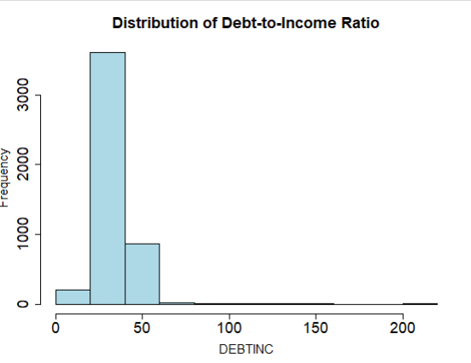
Figure 1: Distribution of Debt-to-Income Ratio (DEBTINC)

  - Debt-to-Income by Default Status
The Figure 2 comparing DEBTINC by default status shows a clear difference between defaulters and non-defaulters. The median debt-to-income ratio for defaulters is approximately 35–38, compared to around 30–33 for non-defaulters, indicating a higher financial burden among borrowers who defaulted. The interquartile range for defaulters is also slightly wider, suggesting greater variability in financial stress.
In addition, defaulters exhibit significantly more extreme values, with DEBTINC extending beyond 100 and reaching close to 200, while most non-defaulters remain below 60. These differences indicate that higher debt relative to income is strongly associated with an increased likelihood of default.
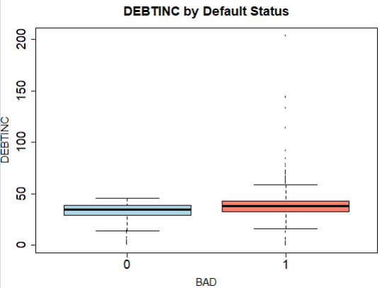
Figure 2: Debt-to-Income Ratio by Default Status

  - Distribution of Debt-to-Income Ratio by Default Status
The Figure 3 shows the distribution of DEBTINC by default status using a density plot. Most borrowers are concentrated between approximately 20 and 50 debt-to-income ratio values. However, borrowers who defaulted (BAD = 1) show a distribution that is slightly shifted toward higher DEBTINC values compared to non-defaulters (BAD = 0).
The density for defaulters remains more spread out beyond 50 and extends past 100, with some extreme values reaching close to 200. In contrast, non-defaulters are more heavily concentrated around the lower and middle ranges. These patterns suggest that borrowers with higher debt relative to income are more likely to experience financial stress and default on their loans.
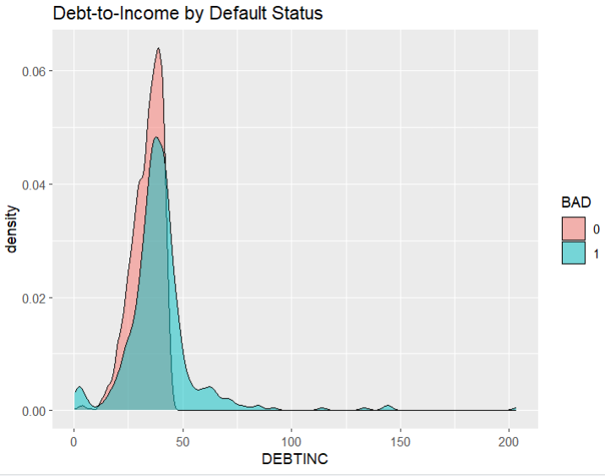
Figure 3: Distribution of Debt-to-Income Ratio by Default Status

  - Delinquency by Default
The Figure 4 (Number of Delinquent Credit Lines) shows a clear and pronounced difference between defaulters and non-defaulters. For non-defaulters, the median delinquency is 0, and the majority of values remain at or near zero, with only a few outliers reaching around 5. In contrast, defaulters show a higher spread, with the interquartile range approximately between 0 and 2 and values extending up to 5 within the main distribution.
Additionally, defaulters exhibit several extreme outliers, with delinquency counts reaching as high as 15. These patterns indicate that borrowers with a history of multiple delinquent accounts are significantly more likely to default.
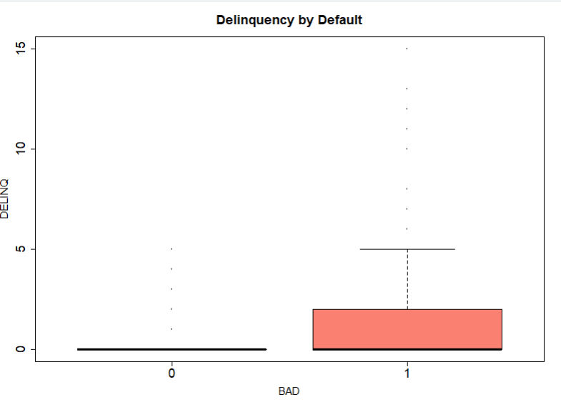
Figure 4: Delinquency by Default Status

  - Distribution of Default (BAD)
The Figure 5 shows the distribution of the target variable BAD. The non-default group (BAD = 0) has around 4,700–4,800 borrowers, while the default group (BAD = 1) has around 1,100–1,200 borrowers. This shows that non-default borrowers are much more common than default borrowers in the dataset.
Although the dataset is imbalanced, the default group still has enough observations to support meaningful borrower risk analysis and predictive modeling.
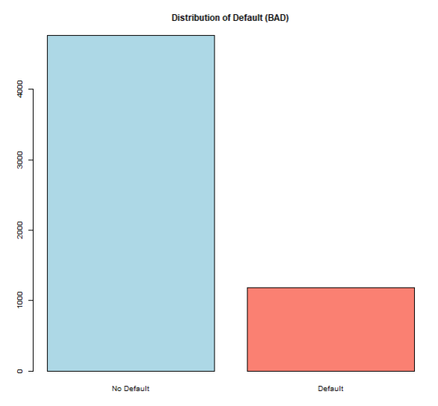
Figure 5: Distribution of Borrowers by Default Status

  - Relationship Between Loan Amount and Property Value
The Figure 6 shows the relationship between LOAN and VALUE using a scatter plot. Most borrowers are concentrated in the range of approximately 5,000 to 30,000 for loan amount and below 150,000 for property value. The plot shows a general positive relationship, where larger loan amounts are usually associated with higher property values.
However, the relationship is not perfectly linear, as there is noticeable variation in property values for similar loan amounts. Several extreme observations are also visible, with some loan amounts extending close to 90,000 and property values exceeding 800,000. These patterns suggest that while property value strongly influences loan amount, additional borrower and financial characteristics may also affect lending decisions.
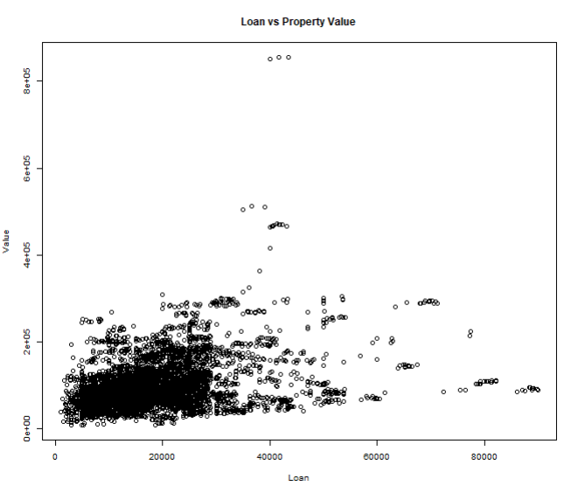
Figure 6: Scatter Plot of LOAN vs VALUE
  - Outlier Detection
The Figure 7 was used to examine potential outliers in LOAN, VALUE, and DEBTINC. For LOAN, the median is approximately 15,000–17,000, with most values between 10,000 and 22,000, but several extreme observations extend beyond 40,000 and reach close to 90,000. Similarly, for VALUE, the median property value lies around 80,000–100,000, with the majority of observations below 200,000, while extreme values exceed 400,000 and approach 800,000. For DEBTINC, most values are concentrated between 25 and 40, but outliers extend beyond 100 and reach close to 200.
These extreme values reflect genuine variation in loan size, property value, and financial burden rather than data entry errors. Therefore, they were retained, as they capture important high-risk and high-exposure borrower profiles that are critical for accurate credit risk analysis.
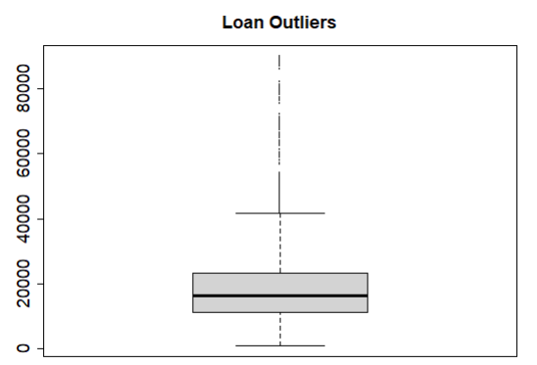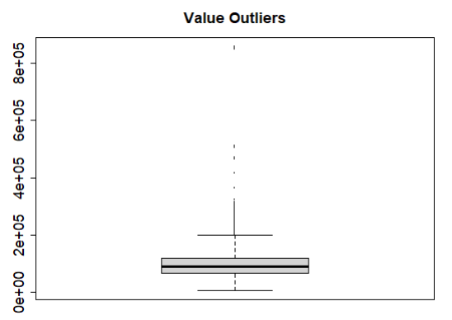
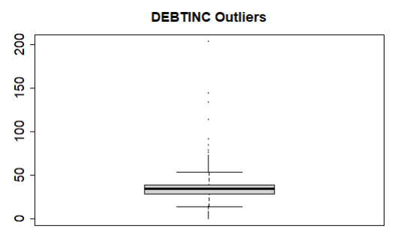
Figure 7: Loan Amount, Property Value and Debt-to-Income Ratio Outlier Detection

  - Correlation and Multicollinearity
The Figure 8 correlation matrix was used to examine the relationships among the numerical variables in the dataset. The results show that variables related to financial stress and past credit behavior, such as DELINQ, DEROG, and DEBTINC, have moderate positive correlations with the default variable (BAD). In particular, DELINQ and DEBTINC show stronger positive relationships with BAD compared to most other variables, indicating that borrowers with more delinquent accounts and higher debt-to-income ratios are more likely to default.
Among the predictor variables, the strongest correlation is observed between MORTDUE and VALUE, with a correlation of approximately 0.88–0.90. This strong positive relationship is expected because larger property values are generally associated with higher outstanding mortgage balances. Moderate positive relationships are also visible between LOAN and MORTDUE, as well as between LOAN and VALUE.
To further assess multicollinearity, a Variance Inflation Factor (VIF) analysis was conducted. All VIF values were below commonly accepted thresholds (e.g., VIF < 5), suggesting that multicollinearity is not a significant concern in this dataset. Therefore, no variables needed to be removed, and all predictors were retained for subsequent modeling.
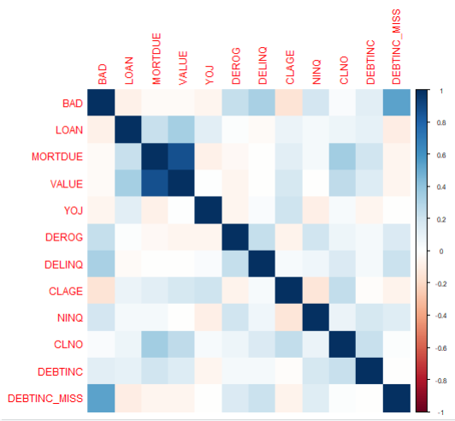
Figure 8: Correlation Matrix of Numerical Variables

  - Predictor Analysis and Variable Relevance
The predictors in this dataset represent borrower financial condition, credit behavior, property value, and loan characteristics. These variables help explain borrower risk patterns and support the bank’s goal of making more consistent and data-driven lending decisions.
Among the predictors, DELINQ, DEROG, and DEBTINC appear to be some of the most important indicators of borrower risk. These variables show noticeable differences between borrowers who defaulted and those who did not. Borrowers with higher numbers of delinquent credit lines and derogatory reports tend to have a history of repayment problems, which increases the likelihood of future default. The DEBTINC_MISS variable also showed that missing financial information itself may contain important signals related to borrower risk. Similarly, a higher debt-to-income ratio (DEBTINC) indicates greater financial burden and reduced ability to repay additional debt.
Other variables provide supporting information about borrower stability and credit experience. For example, CLAGE reflects the length of a borrower’s credit history, while NINQ indicates recent credit inquiries that may signal increased borrowing activity or financial stress.
In the classification analysis, VALUE was used as a predictor variable to help explain borrower default risk. In the regression analysis, VALUE served as the target variable to examine how borrower and loan characteristics relate to property value. These variables are especially important for understanding property value patterns and lending exposure.
Overall, the predictors capture important dimensions of borrower risk, including financial capacity, past credit behavior, credit experience, and collateral characteristics. These variables provide the foundation for building models that help the bank better understand borrower risk patterns, predict property value, and improve the consistency of lending decisions.
The statistical comparisons and visual analysis consistently show that DELINQ, DEROG, and DEBTINC are higher among defaulters, reinforcing their importance as key indicators of lending risk.

Dimension Reduction
Dimension reduction techniques such as Principal Component Analysis (PCA) were considered during exploratory analysis to address potential correlation among predictors. However, PCA was not applied at this stage because the primary objective is to maintain interpretability and clearly understand how individual variables relate to borrower risk and property value. Retaining the original variables allows for more meaningful business insights and supports transparent credit decision-making.

Data engineering and transformation
Several data preparation and transformation steps were performed to improve data quality and enhance model performance. First, blank values in the categorical variables REASON and JOB were converted into missing values (NA). These blank entries represented missing information and treating them as NA allowed them to be properly handled during preprocessing. Proper handling of missing values is important because leaving them as blank strings can lead to incorrect analysis and reduce model reliability.
A new variable called DEBTINC_MISS was created to indicate whether the Debt-to-Income ratio (DEBTINC) was missing. The absence of financial information can itself be informative, as borrowers who do not report certain details may differ systematically from those who provide complete data. Including this indicator variable allows the models to capture potential patterns associated with missing financial information and improve understanding of borrower risk patterns.
Missing values in the dataset were handled using Multiple Imputation by Chained Equations (MICE) with predictive mean matching. This method estimates missing values based on relationships with other variables rather than replacing them with simple averages. As a result, the imputed values remain realistic and preserve the natural variability of the data, reducing bias and maintaining meaningful relationships between predictors and the target variable.
In addition, the categorical variables REASON and JOB were transformed into dummy variables so they could be used in predictive models. Since many machine learning algorithms require numerical inputs, dummy encoding converts each category into binary indicators, allowing the models to effectively incorporate categorical information during training.
To address class imbalance in the target variable BAD, where non-default cases significantly outnumber default cases, the SMOTE (Synthetic Minority Over-sampling Technique) method was applied to the training data for the classification models. SMOTE generates synthetic observations for the minority class, improving the model’s ability to learn patterns associated with loan defaults and reducing bias toward the majority class. SMOTE was applied only for classification models predicting BAD and was not used for the regression analysis predicting VALUE.
In addition to these preprocessing steps, clustering analysis was performed as an exploratory technique to identify natural groupings of borrowers based on their financial and credit characteristics. Numerical variables such as LOAN, VALUE, DEBTINC, DELINQ, and DEROG were standardized prior to clustering to ensure equal contribution from each variable. A k-means clustering approach revealed distinct borrower segments representing different risk profiles, where high-risk groups were characterized by higher debt-to-income ratios and greater delinquency levels. This provided additional insight into borrower heterogeneity and supported a deeper understanding of risk patterns in the dataset.
Overall, these data preparation and transformation steps improved the dataset and created a strong foundation for building reliable and interpretable predictive models.

Data partitioning methods
The dataset was divided into training and testing sets using a 70%–30% split. The training set was used for all data preparation steps, including imputation, dummy variable creation, SMOTE, and model training. The remaining 30% of the data was reserved as the testing set and used only for evaluating model performance. This approach allows the models to be tested on unseen data, providing a more realistic estimate of how they may perform in real-world lending situations.
The split was performed using the createDataPartition() function from the caret package, which applies stratified sampling. This method preserves the proportion of default (BAD = 1) and non-default (BAD = 0) cases in both the training and testing sets. Maintaining the class distribution is especially important because the dataset is imbalanced, and preserving the distribution helps support more reliable and unbiased model evaluation.

Model selection and justification
Since this analysis includes both prediction of borrower default risk and prediction of property value, both classification and regression models were selected. The target variable BAD has two possible outcomes (default and non-default), making classification techniques appropriate for default prediction. In contrast, VALUE is a continuous numerical variable, making regression techniques appropriate for predicting property value. The selected models include Logistic Regression, Decision Tree, Random Forest, Naive Bayes, and Linear Regression. These models represent different machine learning approaches and allow for a comprehensive comparison of predictive performance.
In addition to predictive models, clustering (k-means) was included as an unsupervised learning technique to explore natural groupings within the data. While clustering is not used for prediction, it helps identify underlying borrower segments based on financial and credit characteristics, providing additional insight into borrower risk patterns.
Logistic Regression was used as a baseline classification model because it is widely applied in financial and credit risk analysis. It estimates the probability of default based on the relationship between predictor variables and the target variable. Its main advantage is interpretability, allowing a clear understanding of how each variable influences default risk. However, it may not capture complex nonlinear relationships.
Linear Regression was used to predict the continuous target variable VALUE (property value). Since VALUE is numerical, linear regression is an appropriate method for examining how borrower and loan characteristics relate to property value. The model also provides an interpretable baseline for understanding relationships among financial variables.
A Decision Tree model was selected because it produces simple and interpretable decision rules. It segments the data into smaller groups based on predictor variables, making it easy to understand how predictions are formed. This is particularly useful for business decision-making. However, individual trees may overfit the data if not properly controlled.
To improve predictive performance, a Random Forest model was included. This method builds multiple decision trees and aggregates their predictions, resulting in improved accuracy and reduced overfitting. Random Forest is especially effective for structured datasets, although it is less interpretable compared to simpler models.
Finally, Naive Bayes was used as a probabilistic classification approach. It calculates the probability of each class based on predictor variables, assuming independence among them. Although this assumption may not always hold, the model is computationally efficient and often performs well in practice.
Using this combination of models allows for comparison of different modeling approaches, while clustering provides additional insight into borrower segmentation. Together, these techniques support a more comprehensive understanding of borrower risk and property value patterns and help identify suitable approaches for improving lending decisions.

Model fitting and performance evaluation
The selected techniques were fitted using the prepared training dataset after completing preprocessing steps, including handling missing values, creating dummy variables for categorical data, and balancing the classes using SMOTE. A 70% training and 30% testing split was used so that the models could learn patterns from the training data and then be evaluated on a separate unseen dataset. This approach helps reduce overfitting and provides a more realistic assessment of model performance.
Four classification models—Logistic Regression, Decision Tree, Random Forest, and Naive Bayes—were fitted using the balanced training dataset. Each model learned the relationship between the predictor variables and the target variable BAD, which indicates whether a borrower defaults on a loan. After training, the models were applied to the test dataset to generate predictions, allowing their performance to be evaluated on new borrowers.
In addition to the classification models, a Linear Regression model was fitted as a regression technique to predict the continuous target variable VALUE, which represents property value. The model learned the relationship between borrower and loan characteristics and property value using the training dataset. After training, predictions were generated on the testing dataset and evaluated using regression performance metrics.
In addition, k-means clustering was fitted as an unsupervised learning technique to group borrowers with similar financial and credit characteristics. Before clustering, the selected numerical variables were standardized so that variables with larger scales did not dominate the grouping process. The clustering results were then evaluated by examining the characteristics of each cluster and comparing how borrower profiles differed across groups. This made it possible to identify segments with relatively lower or higher risk patterns based on variables such as debt-to-income ratio, delinquency, and derogatory reports.
The performance of the classification models was evaluated using appropriate classification metrics, the regression model was evaluated using regression metrics, and the clustering results were assessed based on the interpretability and distinctiveness of the borrower groups. A detailed comparison of these results is presented in the following section.

Reporting Model Performance
Regression Model Performance
For the regression analysis, Linear Regression was used to predict property value (VALUE). The model achieved an R-squared value of 0.8006 and an adjusted R-squared value of 0.8001, meaning that about 80% of the variation in property value was explained by the predictors.
The model also produced an MAE of 13,416.09, MSE of 699,431,047, and RMSE of 26,446.76. This indicates that the predicted property values were, on average, approximately 13,416 units away from the actual values, while the RMSE shows that larger prediction errors were penalized more heavily.
Overall, the regression model provided a strong fit for predicting property value and demonstrated meaningful relationships between borrower characteristics, loan information, and property valuation.
Classification Model Performance
The performance of the classification models was evaluated using multiple metrics, including accuracy, sensitivity, specificity, precision, Kappa, and AUC. Based on the results, the Random Forest model achieved the highest overall performance, with an accuracy of 88.53% and an AUC of 0.946, indicating excellent ability to distinguish between defaulters and non-defaulters. The model also achieved a Kappa value of 0.636, showing strong agreement between predicted and actual values beyond chance.
In comparison, Logistic Regression achieved an accuracy of 85.57% and an AUC of 0.888, showing strong predictive ability with better interpretability. The Decision Tree model had an accuracy of 86.69% but a lower AUC of 0.848, suggesting weaker overall separation between defaulters and non-defaulters. Naive Bayes showed the lowest performance, with an accuracy of 82.66% and an AUC of 0.868.
Random Forest also achieved high specificity of 93.82%, meaning it correctly identified most non-defaulters. However, its sensitivity was lower at 67.86%, meaning some default cases were missed. Overall, Random Forest provided the best balance of accuracy and prediction ability, making it the strongest classification model for this problem.

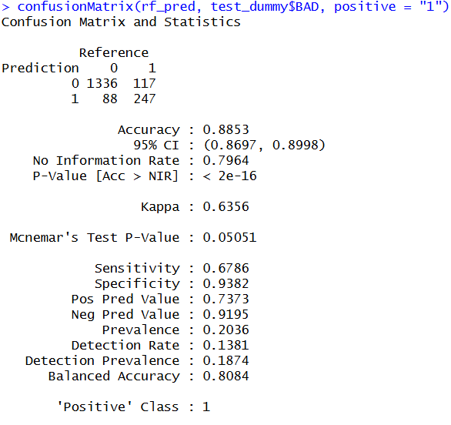
Figure 9: Confusion matrix of Random Forest
The performance of the Random Forest model, identified as the best-performing model, is summarized using the confusion matrix shown in Figure 9. The model achieved an overall accuracy of 88.53%, indicating strong predictive performance. As illustrated in Figure 9, the model correctly classified 1336 non-default cases (true negatives) and 247 default cases (true positives), while misclassifying 88 non-default cases as default (false positives) and 117 default cases as non-default (false negatives). The model demonstrates a high specificity of 93.82%, indicating its strong ability to correctly identify non-defaulters. However, the sensitivity of 67.86% suggests that a portion of default cases are still being missed. The precision of 73.73% further indicates that when the model predicts a default, it is correct a majority of the time. Overall, the Random Forest model provides a well-balanced performance across multiple evaluation metrics, making it the most effective model among those evaluated.
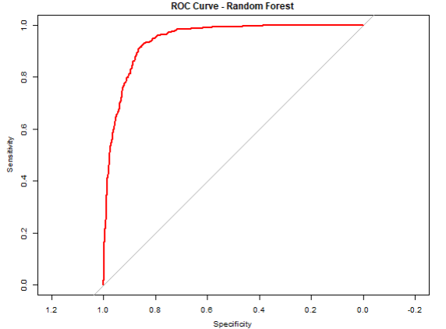
Figure 10: ROC Curve of Random Forest Model

The ROC curve for the Random Forest model is presented in Figure 10, illustrating the model’s ability to distinguish between defaulters and non-defaulters across different classification thresholds. As shown in Figure 10, the curve is positioned close to the top-left corner, indicating a strong balance between sensitivity (true positive rate) and specificity (true negative rate). This reflects the model’s ability to correctly identify defaulters while maintaining a low false positive rate.
The model achieved an Area Under the Curve (AUC) of approximately 0.946, indicating excellent discriminative performance. In practical terms, this means there is a 94.6% probability that the model will rank a randomly selected defaulter higher than a randomly selected non-defaulter. Compared to a random classifier, represented by the diagonal reference line with an AUC of 0.5, the Random Forest model performs substantially better in identifying high-risk borrowers.
The steep initial rise of the ROC curve further indicates that the model is highly effective at identifying defaulters even at lower threshold values. Overall, the ROC curve confirms that the Random Forest model provides superior predictive performance, making it a strong and reliable model for this classification problem.

Clustering Performance and Interpretation
K-means clustering was performed to identify natural borrower segments based on financial and credit characteristics. Before clustering, the selected numerical variables were standardized to ensure that variables with larger scales did not dominate the grouping process.
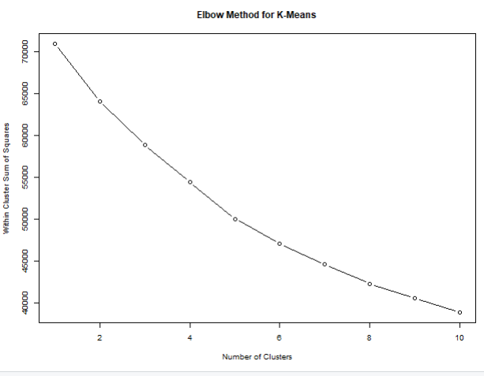
Figure 11: Elbow Method for K-Means
The elbow method was used to determine the appropriate number of clusters for the analysis. Within-cluster sum of squares (WSS) was calculated for cluster values ranging from 1 to 10. As shown in Figure 11, the WSS decreased rapidly at lower values of k and began to level off around k = 3, indicating diminishing improvement beyond this point. Based on this elbow pattern, three clusters were selected for the final clustering analysis because they provided a reasonable balance between cluster separation and model simplicity.
Using k = 3, the clustering analysis produced three borrower groups containing approximately 1,490 borrowers in Cluster 1, 1,995 borrowers in Cluster 2, and 687 borrowers in Cluster 3. The clusters showed noticeable differences in borrower financial characteristics and default behavior. One cluster contained borrowers with higher debt-to-income ratios, delinquent credit lines, and derogatory reports, indicating relatively higher default risk. Another cluster showed comparatively lower financial stress and lower levels of default, suggesting a lower-risk borrower group.
Silhouette analysis was also conducted to evaluate cluster quality. The average silhouette width was approximately 0.138, indicating relatively weak separation between clusters. This suggests that although meaningful borrower groupings were identified, there is still overlap among borrower profiles due to similarities in financial and credit characteristics. Despite the modest silhouette value, the clustering analysis provided useful exploratory insight into borrower segmentation and risk patterns

Model Evaluation
The Random Forest model, selected as the final classification model, performed very well based on different evaluation measures such as accuracy, sensitivity, specificity, precision, and AUC. The model achieved an accuracy of 88.53% and an AUC of 0.946, showing that it is very good at separating borrowers who defaulted from those who did not default. The model also achieved high specificity (93.82%), meaning it was very effective at correctly identifying borrowers who would not default. In addition, the precision value of 73.73% shows that when the model predicted a borrower would default, it was correct most of the time.
However, the model was not perfect. Its sensitivity (67.86%) was lower than its specificity, meaning that some borrowers who actually defaulted were missed by the model. In real-world lending, missing risky borrowers can lead to financial losses. This shows a trade-off in the model: it is very strong at avoiding false alarms and correctly identifying non-defaulters, but it is not as strong at catching every defaulter. Depending on the business goal, the model can be adjusted to improve sensitivity if identifying more risky borrowers becomes more important.
In addition to the classification analysis, the Linear Regression model used to predict property value (VALUE) also showed strong performance. The model achieved an R-squared value of 0.8006, meaning that about 80% of the variation in property value was explained by the predictors used in the model. The model also produced an MAE of 13,416.09 and an RMSE of 26,446.76, showing that the predicted property values were reasonably close to the actual values. Variables such as MORTDUE and LOAN showed positive relationships with property value, while higher NINQ and DEBTINC values were linked to lower predicted property values.
Overall, both the Random Forest and Linear Regression models showed strong performance and provided useful insight into borrower risk and property value. Together, these models can help the bank make more consistent, reliable, and data-driven lending decisions.

Observations and Conclusion
The analysis shows that borrower financial behavior is very important in predicting loan default. Variables such as DELINQ, DEROG, NINQ, and DEBTINC were generally higher among borrowers who defaulted, while non-defaulters usually had longer credit histories (CLAGE) and more stable financial behavior. These findings suggest that past financial behavior is a strong indicator of future loan risk.
Among the classification models, the Random Forest model performed the best, achieving the highest accuracy and AUC. This shows that the model is very effective at separating defaulters from non-defaulters. However, the model was better at identifying safe borrowers than risky borrowers, meaning that some actual defaulters were still missed. This is important because missing risky borrowers can lead to financial losses.
The Linear Regression model used to predict property value (VALUE) also showed reliable performance, explaining about 80% of the variation in property value. The results indicate that borrower financial characteristics and loan-related variables have meaningful relationships with property value and can support more consistent property valuation decisions.
In addition, the clustering analysis helped identify borrower groups with different financial characteristics and risk levels. Some clusters showed higher debt levels, delinquency, and default rates, while other clusters represented more stable and lower-risk borrowers. Although the cluster separation was not very strong, the analysis still provided useful insight into borrower segmentation and risk patterns.
Overall, the results show that data-driven models and analytical techniques can help banks make more consistent and reliable lending decisions, reduce financial risk, improve property valuation, and better understand borrower behavior.

